**Inner Join**

What are Joins and its Use?

-- As we know, SQL is a programming language that is used to interact with database.

-- In a relational database, the data is stored across multiple tables and all these tables will be related to one another in one way or the other.

-- If we want to fetch all or some of these details of the data scattered across the different tables, the only way to fetch these details is using joins or by joining the required tables together.

-- From the single query, you will be able to fetch the data from multiple tables.

-- There are several types of joins. And depending on your requirement, you must use one type of join or the other.

Inner Join

-- In PostgreSQL the INNER JOIN keyword selects all rows from both the tables as long as the condition satisfies.

-- This keyword will create the result-set by combining all rows from both the tables where the condition satisfies i.e value of the common field will be the same.

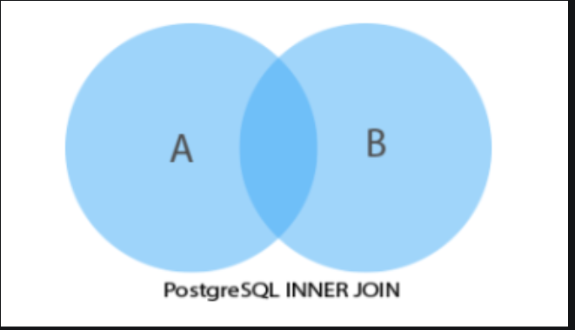

-- **Syntax:**

*SELECT table1.column1, table1.column2, table2.column1, ....*

*FROM table1*

*INNER JOIN table2*

*ON table1.matching_column = table2.matching_column;*

*table1: First table.*

*table2: Second table*

*matching_column: Column common to both the tables.*

1. Fetch all the employee's first name, last name and their respective department names.

SELECT

dev_schema.employee.first_name, dev_schema.employee.last_name,

dev_schema.department.department_name

FROM

dev_schema.employee INNER JOIN dev_schema.department

ON

dev_schema.employee.fk_department_id = dev_schema.department.department_id;

SELECT

emp.first_name, emp.last_name,

dept.department_name

FROM

dev_schema.employee as emp INNER JOIN dev_schema.department as dept

ON

emp.fk_department_id = dept.department_id;

2. Fetch employee names, salary and job title.

SELECT

emp.first_name, emp.last_name, emp.salary,

job.job_title

FROM

dev_schema.employee as emp INNER JOIN dev_schema.job as job

ON emp.fk_job_id = job.job_id;

3. Fetch employee names with their job title and department.

SELECT

emp.first_name, emp.last_name,

job.job_title, dept.department_name

FROM

dev_schema.employee as emp INNER JOIN dev_schema.job as job

ON emp.fk_job_id = job.job_id

INNER JOIN dev_schema.department as dept

ON emp.fk_department_id = dept.department_id;